concat()

arr=["gmy","xyz","abc"];

arr2=["wow","kool","cool"];

arr.concat(arr2);

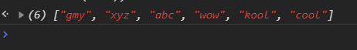

every()

marks=[35,35,34,32,91];

console.log(marks.every((item)=>item<30));

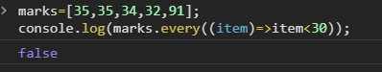

filter()

marks=[35,35,34,32,91];

console.log(marks.filter((item)=>item>35));

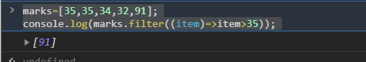

forEach()

marks.forEach(item=>console.log(item))

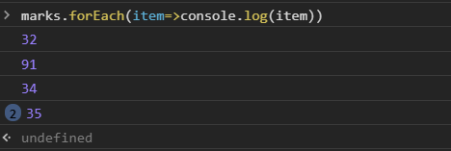

join()

var gmy=marks.join(",")

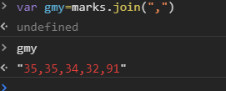

lastindexOf()

marks.lastIndexOf(35)

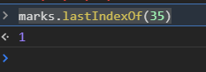

map()

console.log(marks.map(item=>item=item+1))



pop()

console.log(marks.pop())



push()

console.log(marks.push(91))

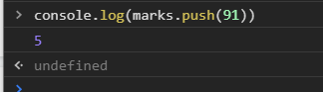

reduce()

var gmy=marks.reduce((gmy,item)=>gmy=gmy+item);

console.log(gmy);

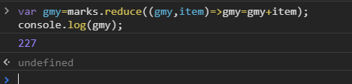

reverse()

console.log(marks.reverse())

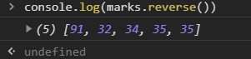

reduceRight()

gmy = [[0, 1], [2, 3], [4, 5]].reduceRight(

(accumulator, currentValue) => accumulator.concat(currentValue)

);

console.log(gmy);

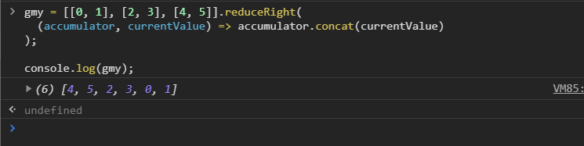

shift()

console.log(marks.shift())

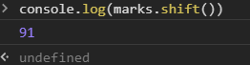

slice()

console.log(marks.slice(1,3))

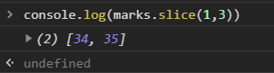

some()

console.log(marks.some(item=>item%2==0));

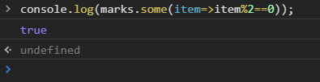

sort()

arr.sort()

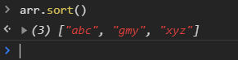

splice()

marks.splice(1,0,91)

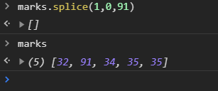

toString()

var gmy=123

str=gmy.toString()

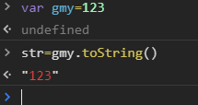

unshift()

console.log(marks.unshift(91.99,100))

7

